Health and Safety Policy

Positive safety culture
The purpose of this document is to contribute to a positive safety culture in the St Paul’s School Boat Club. A positive safety culture should result in all members of the Boat Club taking care to keep themselves and others safe. In brief, a positive safety culture would exist if all members of the Boat Club would:
- Consider safety when deciding whether to start, or continue, an activity.
- Check their boats before going afloat.
- Take care when handling boats.
- Follow the instructions of their cox and coach.
- Take care when launching.
- Dress appropriately for the conditions.
- Always abide by the rules of the river.
- Keep a good lookout when afloat.
- Report all the incidents that they see and consider how they could have been avoided.
- Take care when coming ashore.
- Look after equipment and report any breakages to a coach or member of Boathouse staff.
This document is a summary of Health and Safety practices and rules in the Boat Club. This document should be read in conjunction with:
- Rowing Risk Assessment
- Boathouse Risk Assessment
- Workshop Risk Assessment
- Training Camp Risk Assessment
- Boat Club Standard Operating Procedures (SOPs)
- Boathouse Gym Rules for Unsupervised Training

British Rowing Club Water Safety Audit (CWSA) requirements
The national governing body for rowing, British Rowing (BR), requires all rowing clubs to complete a Club Water Safety Audit each year. As part of this process, BR requires all clubs to submit the documentation listed below. The location of each document within the St Paul’s School Boat Club documentation is listed alongside each document: all documents are published on the school’s intranet at https://intranet.stpaulsschool.org.uk/boat-club/safety.
- Safety Policy
  - This document is the safety policy
- Club Safety Plan
  - This is contained within this document under the heading “Safety Plan”
- Emergency Response Plan
  - This is contained within this document under the heading “Emergency Response Plan”
- Risk Assessments for Club Activities
  - These are the “Rowing Risk Assessment” and “Boathouse Risk Assessment”
- Risk Assessments for Training Camps
  - This is the “Training Camp Risk Assessment”

Staffing 2025-2026
Role | Name | H&S Responsibilities
President of the Boat Club | Matthew Smith | To ensure the pastoral  welfare of pupils is in enhanced by involvement in the Boat Club.  To provide proactive leadership that supports legal compliance and positive safety culture.
Director of Rowing* | Bobby Thatcher | To manage health and safety within the Boat Club as described in section 4 of the School’s H&S policy.  To provide proactive leadership that supports legal compliance and positive safety culture.  To ensure Risk Assessments of Boat Club activities are maintained up to date, ensuring that Risk Assessments are reviewed:  >When an accident or near miss occurs;  >Annually or before the review date;  >When the activity/task/equipment changes;  >When legislation or best practice advice changes.  To ensure all health and safety information, relevant to the Boat Club is shared with coaches.  To ensure induction and refresher safety training is undertaken.  To participate in accident investigations relating to injuries and incidents reported on accident forms.
Boatman* | Dickie Twyman | To maintain the Boat Club’s fleet in a safe condition.  To manage the Boat Club’s damage reporting and quarantine systems.  To maintain a record a record of maintenance and safety checks relating to Boat Club equipment, including vehicles, trailers, gym equipment and launch engines.
Rowing Professional and Boathouse Administrator* | Sam Lapage | To act as the Boat Club’s Club Water Safety Officer.  To ensure the delivery of rowing activities follows the best practice advice in British Rowing’s RowSafe.  To carry out the annual British Rowing Club Water Safety Audit.  To maintain a record a record of maintenance and safety checks relating to Boat Club equipment, including electronics, lifejackets and launch safety kits.
Rowing Professional and Boathouse Manager * | German Pradera Anllo | To take the lead responsibility for maintaining the Boathouse and its facilities in a safe, clean, tidy and ready state.
Rowing Professional* | Tom Wilkinson | To safeguard the welfare of pupils in the Boat Club and act in accordance with school and Boat Club policies.
Teachers coaching rowing | Nick Friend, Tom Killick, Chris Harrison, Doug Perrin, Ed Bailey
Casual rowing coaches | Charles Bourne, Jon Whybrow, Seb Benzecry,  Annie Wertheimer, Harry Jenkins
Rowing gap assistants
*Full time Boathouse staff

Staff training

Induction
When joining the Boat Club, all new members of staff receive training as set out in the “Staff inductions” section of the Standard Operating Procedures; this is in addition to general induction training organised by the school. In addition, new staff are required to complete the annual checks – as set out below – at the point at which they join.
Members of Boathouse staff are invited to start-of-term INSET meetings for teaching staff, which include training on safeguarding updates.
All coaches are required to hold RYA Level 2 Powerboat qualification before being allowed to drive a launch.

Annual checks
At the start of each academic year, all coaches are made aware of any updates to important documentation relating to the Boat Club and sport at the school. All coaches are required to read, and confirm by completing a form, that they have read the following documents:
- Health and Safety Policy
- Rowing Risk Assessment
- Guidance for Away Fixtures
- Guidance and Reminders when doing Demonstrations in Sport
- Nutritional Supplement Protocol
- Boat Club Rules and Agreements

First Aid
The school arranges regular First Aid training, allowing all members of Boathouse staff and as many coaching staff as possible, to maintain accreditation.

Training for all school staff
The school organises and maintains records of training that is general to all staff, for example for safeguarding, working at height, fire safety, manual handling and driving passenger-carrying school vehicles.

Safety Plan
The Club Safety Plan and Rules (see RowSafe 3.2) describe what members and others should do to make an incident less likely to happen.
This section lists the Boat Club’s safety rules, with commentary in several categories, which follow from the various Risk Assessments. Rules are denoted by bullet points.

Going afloat rules
The Rowing Risk Assessment contains mitigations for several situations that present greater hazards than usual on the river: low light conditions, strong stream conditions, cold weather, lightning and rowing in small boats.
- Before going afloat, every coach must conduct a dynamic risk assessment to take into account the prevailing conditions, the capabilities of their crew and their own capabilities.
- All coaches must carry a mobile phone when afloat.
- When coaching inexperienced crews, coaches should carry a working megaphone.
- All crews should navigate in line with Tideway Code.
- Small boats must stay within eyesight of their coach’s launch.
- Coaches must check the lifejackets of novices are properly worn.
- All athletes must follow the directions of their coach, and rowers should follow the directions of their steersperson.

Rowing on flags
The Port of London Authority (PLA) maintains a flag system to inform recreational activity on the tidal Thames (details are in the Tideway Code, p 15). Rowing on the flood tide is not forbidden on any flag, however, an outing that is permissible according to the PLA flag system may be unsafe because of prevailing conditions, the capabilities of the crew and the capabilities of the coach. Experienced athletes with experienced coaches may be able to safely handle yellow flag ebb tide conditions, but inexperienced athletes and coaches will be much less able to cope safely.

Yellow flag, strong stream and cold weather rules
- For J15 athletes in fast and cold conditions (i.e. yellow flag conditions on the ebb tide) and only when it is safe to do so:
  - Take only coxed boats afloat and do not use novice steersmen.
  - Plan the outing to avoid rough water (especially any foreseeable wind against tide areas).
- J14 athletes should not go afloat if:
  - The PLA flag is yellow and any part of the outing would take place on the ebb tide.
  - The air temperature is less than 4 °C.
- For all athletes: go afloat only if the whole crew is wearing suitable kit (in the case of very cold weather, this means long sleeves, leggings and layers).

Low light rules
- Only J16 and senior crews are allowed to row in low light conditions.
- If only one coach is going afloat, no small boats are to be taken out (i.e. fours and eights only).
- Less-experienced oarsmen to be restricted to fours and eights only - no small boats.
- Lights to be fixed to boats as per RowSafe requirements.

Lightning rules
During a thunder storm, crews should not go afloat. When assessing conditions or responding to an unexpected thunder storm, British Rowing’s 30/30 rule should be applied: “if the flash to bang time is 30 seconds, or less, then find shelter. Stay there until 30 minutes after the last clap of thunder.”

Novices rules
Creating a positive safety culture amongst pupils begins with a series of induction activities, as described in the SOPs. In the spring term of their J14 year, pupils follow an induction programme that includes: swim tests (in the school swimming pool), capsize drills (in the school swimming pool), training in boat handling, training in safe rowing technique, training in the use of lifejackets and buoyancy aids and training in simplified Tideway navigation.
During the first few weeks of J14 rowing, and with similarly novice crews at other times:
- At least one additional coach should help a crew to boat.
- Coaches should get their launch engine running and coach go afloat before their crew pushes off. The additional coach can manage the novice crew while the coach goes afloat.

Launch rules
- All coaches are required to hold RYA Level 2 Powerboat qualification before being allowed to drive a launch. For new coaches, launch training is a part of induction, as set out in the SOPs.
- All passengers in launches – except those being rescued from the water – are required to wear a buoyancy aid. The Boat Club provides self-inflating buoyancy aids for coaches, which are different from the manually-inflating buoyancy aids provided for coxes.
- Launch drivers are required to attach a kill cord at all times while the engine is running. Launch drivers should go afloat only if their launch has a complete safety kit and paddle and after they have checked that the drainage bung is in place.
Emergency contacts are displayed in each launch, on a sheet fixed to the bench, and are also in the Emergency Response Plan.
- The Tideway Code (pp 44-45), published by the Port of London Authority (PLA), describes how coaching launches should navigate:
  - Launches should follow their crew either line astern of their crew, on the outside of their crew (only when going downstream in the Fairway) or on the opposite side of the river.
  - Launches carrying more than 2 people must not exceed the speed limit of 8 knots at any time.
  - Coaching launches may travel faster than the speed limit of 8 knots only when directly coaching a crew.

Gym rules
- No unsupervised training is allowed, except as described by the Boathouse Gym Pupil Rules.
- Appropriate footwear must be worn at all times in the gym.

Damaged equipment rules
When damaged equipment is discovered, it should be reported right away, so that it can be repaired. If the damaged equipment would be unsafe to use, it should be quarantined right away so that it is not used by others until it is repaired.
- Damage to equipment should be reported using the online Damage Reporting System, which will share information with the Boathouse staff. QR codes for the system are located in the boat bays.
- Damaged equipment should be quarantined by attaching a “DO NOT USE” sign.
- Damage to school vehicles and trailers should also be reported to the School Vehicle Manager.

Security rules
The Boathouse is on the edge of the school site, and can be a vulnerable point of site security. The site and its perimeter are patrolled 24 hours a day, 7 days a week by the school’s security team as described in the school’s Security, Access Control, Workplace Safety & Lone Working policy. The security team is aware of times of high tide, when there is a particular risk that members of the public on the towpath will attempt to escape rising water by intruding on the school site.
The pupil changing room, staff changing room and workshop have automatic closers and are secured with either code locks or fob locks.
- The last coach to leave the Boathouse must ensure all external doors and gates are closed and secure.
- Coaches must ensure that all doors and gates on the river side of the Boathouse are closed and secure when the Boathouse is unattended.
- Pupils should not be allowed use the Boathouse as an exit from the school site.
- Pupils are instructed not to leave valuables in the Boathouse changing room or anywhere else around the Boathouse.

Health, illness and injury rules
Regular rowing activity brings pupils into contact with the River Thames, which can be a source of waterborne diseases, injury and infection.
- All athletes must wear protective footwear when going afloat.
- All athletes must be fully dressed outside of the changing room.
- In very cold weather, all athletes must wear long sleeves and leggings and coxes and coaches must be warmly dressed.
Coaches strongly encourage pupils to:
- Bring a water bottle to training, especially in warm weather.
- Not to share water bottles, to reduce the risk of transmitting infection.
- To wear sunscreen when UV levels are high. A sun cream dispenser is located in the boat bays.
- Wash their hands after a session. A hand sanitiser dispenser, with signage encouraging pupils to use it, is installed at the exit to the pupil changing room.
The coaches’ changing room has sinks with soap for hand washing.
The list of pupils with life threatening conditions is reviewed each term by the Boat Club, as described in the SOPs, to allow for safe planning of training and away fixtures.
Coaches give regular reminders, as described in the SOPs, to pupils about how to best recover from illness and injury with the general guidance being for athletes to communicate candidly with their coaches and to recover fully before re-joining the training programme. To ensure a unified approach, the Boat Club’s approach is stated in the SPSBC Parental Briefing, which is shared with parents of pupils in the Boat Club.

Maintenance logs
The Boat Club keeps maintenance logs for equipment with a core safety function. Checks and services are carried out on a schedule as described in the SOPs.
- Rowing boats – inspected informally before every outing and formally each year
  - The “Boat check” checklist of items for formal inspections is in the SOPs
- Motor launches
  - Engines – serviced twice annually
  - Safety kits – inspected and refreshed each term
- Boat trailers – serviced annually by a professional mechanic
- Rowing machines – serviced at least annually by professional technicians
- Lifejackets – inspected and inflation tested twice annually
- Megaphones – inspected each term
The maintenance logs are accessible from the Boat Club Safety pages of school intranet.

Emergency Response Plan

Incidents on land

When an injury or medical emergency occurs:
- Take control of the situation and remember the basic First Aid rule. Do not move the injured person. If they cannot move by themselves, do not move any part of their body.
- Make sure bystanders are out of danger and supervised.
- Assess and evaluate the injury. Decide whether further assistance is required.
  - If the case is severe, immediately call 999 and ask for an ambulance.
    - Ensure that the person who has called 999 is able to explain the state of emergency and the exact location. Make sure they report back to the scene of the injury with the estimated arrival time of ambulance if one has been called.
    - Ask somebody wait at the entrance of the school for the ambulance.
    - If possible, also summon assistance from the school. It may be faster to send someone for assistance than to phone the emergency contacts.
    - Accompany the injured person to hospital if necessary.
    - If a pupil is the casualty, contact their parents/guardians as soon as is practical.
  - If the case is less severe, send someone to get help from the school, administer First Aid or take the person to the Health Centre. The Health Centre is staffed only during the school day.
    - If a pupil is the casualty and they are not transferred to the Health Centre, contact the pupil’s parents/guardians and tutor.
- Fill in an Accidental Injury Report Form at https://intranet.stpaulsschool.org.uk/handbook/forms-a-z/accidental-injury-report-form.

Incidents afloat
Many incidents afloat can be managed by a lone coach in a launch with a safety kit, however, in the event of a medical emergency or persons in the water (especially if the weather is cold), contacting the emergency services is likely to be the fastest way to help those in danger. This is especially important if tending to a casualty would mean letting a crew out of the coach’s supervision.

When an emergency arises:
- Call 999 and ask for “London coastguard”.
- If people are in the water, tell them to stay with the boat, if possible, and to activate their lifejacket, if they are wearing one.
  - In almost all circumstances when people capsize they should stay with the boat and use it as a floatation device, ideally keeping their torso out of the water to guard against cold water shock and hypothermia.
- Attempt a man overboard drill if it is safe to do so. Beware of endangering people in the water with the launch’s propellor.
- It may be possible to summon assistance from fellow river users or by phone from the school.
If minor First Aid is required, it is usually best to land to administer it or return to the Boathouse.

Cold water immersion
Cold water immersion can lead to cold water shock and to hypothermia, both of which can lead to drowning. A gasp response when immersed in cold water makes people particularly vulnerable to drowning as they involuntarily take several deep breaths. If they are unable to move their upper body out of cold water, a person may have only 1-2 minutes before they become unable to move.

Hypothermia
On cold days, people may become hypothermic because of a lack of warm clothing. Symptoms of hypothermia include: shivering, pale, blue lips and nails, rapid breathing, wheezing and coughing, fast pulse and slurred speech. Hypothermia should be treated by applying layers of clothing – using the emergency poncho in the launch safety kit if afloat – to warm up the casualty slowly. Hypothermia should not be treated using a hot shower

Incident reporting
Following an incident afloat, even if no injuries have occurred, coaches should complete the school’s Incident Report Form at https://intranet.stpaulsschool.org.uk/handbook/forms-a-z/incident-report-form. This is an important part of record keeping for the school from a pastoral and legal perspective, especially where pupils and members of the public are involved. If an injury to a pupil or member of staff has occurred, coaches should instead complete the Accidental Injury Report Form at https://intranet.stpaulsschool.org.uk/handbook/forms-a-z/accidental-injury-report-form.
British Rowing also asks that coaches complete their incident report form at https://incidentreporting.britishrowing.org/.
From British Rowing: “The purpose of the Incident Reporting system is to learn from incidents and to share that learning to prevent a recurrence. It does not really matter who did what. What does matter is that we understand what happened and have some understanding of why it happened. Please try to avoid any thoughts about fault, blame and guilt; they have no place in Incident Reports.”

First Aid equipment
First Aid kits can be found in the boat bays (adjacent to the gym doors), in the workshop (in the marked cupboard), in each of the Boat Club trucks and in each launch – each of these kits is regularly checked by Boathouse staff and refilled by the Health Centre. The Boat Club has an EpiPen for use on away fixtures, which is kept in one of the trucks (RV73 FVP). There is a defibrillator on the external wall of the Boathouse, facing Big Side.

Phone numbers
Landline telephones at the Boathouse are located in the Coaches’ Office and in the Workshop. When afloat, all coaches must carry a mobile phone and should have the following emergency contacts stored.
- Coaches’ Office extension 2546 (020 8746 5546)
- Boathouse Workshop extension 2568 (020 8746 5568)
- Health Centre extension 2422 (020 8746 5422) (during school day only)
- Reception extension 2594 (020 8746 5594) (during school day only)
- Security Hut extension 2431 (020 8746 5431 or 07919 024 321) (24 hours)
- Night watchman 07765 678 531 (after 1900)

Locations
The nearest hospital to the school with an A&E department is Charing Cross Hospital, Fulham Palace Road, London, W6 8RF.
what3words locations at school:
  - Boathouse (river side) ///cloak.liner.rubble
  - Boathouse (Big Side side) ///pipe.sobs.undulation
  - Boathouse Gym (external doors) ///axed.formed.face
  - Towpath vehicle access (east of Boathouse) ///finds.area.twin
  - School site access (Lonsdale Road) ///hero.prep.noting
  - Workshop (Big Side doors) ///limp.cycles.coast
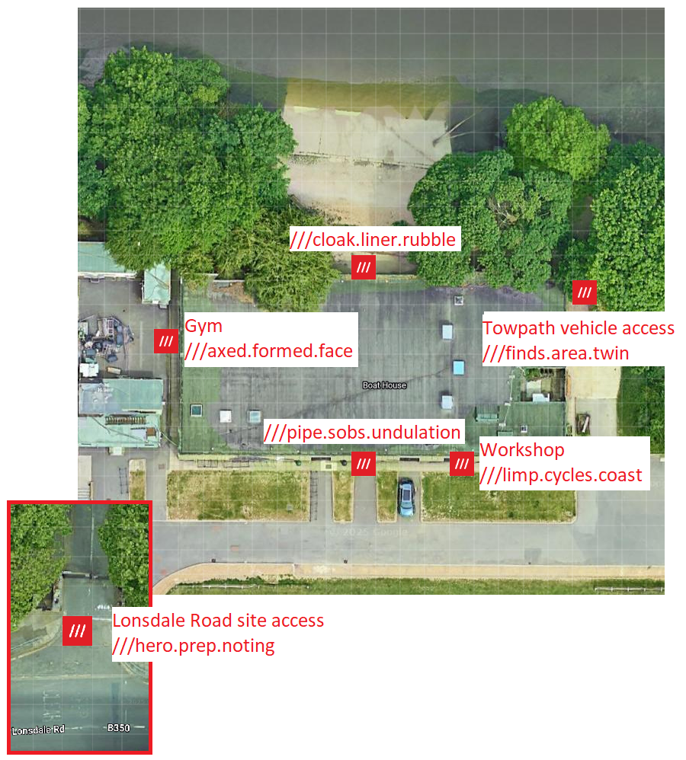

Fire

In the event of fire
- Leave the Boathouse by the nearest exit. Note that the boat bay doors are not fire exits: they may be used as exits only if they are already open.
  - The Boathouse fire exit is in the gym.
  - The Big Side door of the Workshop is a fire exit.
- The Fire Assembly Point is Big Side.

Flammables
Emergency services may need to know the locations of any flammables at the Boathouse.
- Fuel store: petrol (unleaded gasoline) for launch engines is stored in a spillproof, locked site storage box between the north perimeter fence and the Boathouse gym. Coaches have keys to the fuel store.
- Workshop: paints, resins, oils and solvents are stored in yellow metal cabinets in the Boathouse workshop. Bottles of propane and butane are also stored in the workshop and singles bay.

Fire equipment
- Boat bays
  - Adjacent to the middle boat bay doors at the Big Side end of the bay there are two foam extinguishers, two powder extinguishers and a sand bucket
  - Adjacent to the doors of the middle boat bay at both ends of the bay are fire call points
- Gym
  - Adjacent to the external doors there is a foam extinguisher and a CO2 extinguisher
  - Adjacent to the external doors there is a fire call point
- Workshop
  - Adjacent to the Big Side doors there is a foam extinguisher, a powder extinguisher and a CO2 extinguisher
  - Adjacent to the river side doors there is a call point

Appendix: fire
The control of activities related to fire is recorded in the The Fire Safety Policy and Procedures and the Fire Risk Assessment, maintained by the Head of Estates. The school has regular visits from a fire safety advisor, who includes the Boathouse in his assessments.
Fuel for launch engines is stored in a spillproof, locked site storage box between the north perimeter fence and the Boathouse gym. Coaches have keys to the fuel store. Fuel is collected and distributed using 20 L jerry cans with leakproof bayonets.

Asbestos
It is the school’s policy to ensure that all known asbestos is kept in a sealed and stable condition and monitored and managed on a regular basis. The school’s Asbestos Management Plan is available from the Head of Estates. A hard copy is kept in the SPS Reception.

